**Business share application**

**PROJECT REPORT**

***Submitted by***

# B. Balaji Prame (2019272006)

# ***submitted to the faculty of***

**INFORMATION AND COMMUNICATION ENGINEERING**

***In partial fulfillment of the requirement for the degree of***

**MASTER OF COMPUTER APPLICATIONS**



**DEPARTMENT OF INFORMATION SCIENCE AND TECHNOLOGY COLLEGE OF ENGINEERING, GUINDY**

**ANNA UNIVERSITY**

**CHENNAI 600025**

**May 2022**

# **ANNA UNIVERSITY, CHENNAI**

## **BONAFIDE CERTIFICATE**

Certified that this Report titled “**Business share application**” is the bonafide work of **B.Balaji Prame (2019272006)** who carried out the work under my supervision. Certified further that to the best of my knowledge the work reported herein does not form part of any other thesis or dissertation on the basis of which a degree or award was conferred on an earlier occasion on this or any other candidate.

**PLACE**: CHENNAI Mr.J.Duraimurugan

**DATE**: 11/05/2022 TEACHING FELLOW

PROJECT GUIDE

DEPARTMENT OF IST,CEG

**COUNTERSIGNED**

**Dr. S. SRIDHAR**

**HEAD OF THE DEPARTMENT**

**DEPARTMENT OF INFORMATION SCIENCE AND TECHNOLOGY**

**COLLEGE OF ENGINEERING, GUINDY**

**ANNA UNIVERSITY, CHENNAI 600025**

**ACKNOWLEDGEMENT**

Its my privilege to express my sincere thanks to my project guide **Mr. J. Duraimurugan**, TEACHING FELLOW, Department of Information Science and Technology, College of Engineering, Guindy, Anna University, Chennai for her keen interest, inspiring guidance, constant encouragement and support with my work during all the stages, to bring this thesis into fruition.

I deeply express my sincere thanks to **Dr. S. SRIDHAR**, Professor and Head of the Department, Department of Information Science and Technology, College of Engineering, Guindy, Anna University, Chennai for extending support.

0 I would like to express my sincere thanks to the project committee members, **Dr.SASWATI MUKHERJEE**, PROFESSOR, **Dr.M.VIJAYALAKSHMI**, ASSOCIATE PROFESSOR, **Dr.E.UMA**, ASSISTANT PROFESSOR, **MS.C.M.SOWMYA**, TEACHING FELLOW, **MS.P.S.APIRAJITHA**, TEACHING FWLLOW, Department of Information Science and Technology, Anna University, Chennai for giving their valuable suggestions, encouragement and constant motivation throughout the duration of my project.

## **TABLE OF CONTENTS**

|  |  |  |
| --- | --- | --- |
| **CHAPTER NO.**  1 | **TITLE**  **ABSTRACT**  **INTRODUCTION** | **PAGE NO.**  6 |
|  | 1.1 General | 7 |
|  | 1.2 Problem Statement | 7 |
|  | 1.3 Motivation  1.4 Objective | 8  8 |

2 LITERATURE REVI

**ABSTRACT:-**

* This business application will help to create and share ideas between the user where the user can communicate with chat and both the user profile will be verified with the admin panel.

**Profile creation:**

* + First the user wants to create user login will google authentication
  + User will create user profile
  + Idea profile will have some ideas and copyrights and necessary details
  + Resource profile will have the assert type and the personal details and documentation
  + Admin pannel will cross verify those details which the user creates if it’s a un authorized user the admin will not request his process to the portal.
  + After admin approves the idea will get into the database

**Chat Process:**

* + After admin approves the profile will be shown in the application
  + The user can request a chat to the other user if he accept the can share their business ideas
  + If one user wants to deny the other user profile also he can do the option

**CHAPTER 1**

**INTRODUCTION**

**1.1 General:**

* The project is about to gathering individuals to connect together and start a new business solution. Someone might have an idea of the project but they might not have resource to execute the business solution process.
* Someone having a resource to do some business but they don’t have idea of business solution. At this situation our Application play major role to connect these people to become the business partners

**1.2 PROBLEM STATEMENT:**

* There are many person who has idea or have the source to start a business but they need a essential partner to start up the business so this application will help to post their ideas to start up the business
* Business idea person who are looking for partners can update their business ideas here. Once they update their details regarding the ideas, the users can look up the requirement and choose their business ideas.
* The business are categorised according to the different streams . In this, the admin authorises both the business partners’ and the candidates’ personal and business profiles. The business partners can contact the job seekers using the in-built chat box.
* Using AES128 (Advance Encryption Standards) ALGORITHM the password is encrypted and stored in the database so that the details cannot be viewed and the user email will be verified to check whether the user is authorized or not and then the profile will be allowed to post their respective ideas and source in this application

**1.3 MOTIVATION:**

* To share the business ideas to others and solve the unemployment
* To create new business ideas and help others
* Share resource to implement the business ideas
  1. **OBJECTIVE:**
* This application helps to share our ideas and helps us to get the needed resources.we can directly talk with the resource person with the help of in-build chat box

**CHAPTER 2**

**LITERATURE REVIEW:**

|  |  |  |  |  |  |
| --- | --- | --- | --- | --- | --- |
| **S.NO.** | **Paper title** | **Used Technology & Requirments** | **Author Name** | **Published in** | |
| **1.** | **Financial Analysis as a Franchising Tool in Modern Conditions of Digitalization of the Economy** | Framework on franchising agreement, Machine Learning (ML) | Z.P. [Samokhvalova](https://ieeexplore.ieee.org/author/37089190732),  L. I. [Artanova](https://ieeexplore.ieee.org/author/37089191204) | [2021 Intelligent Technologies and Electronic Devices in Vehicle and Road Transport Complex (TIRVED)](https://ieeexplore.ieee.org/xpl/conhome/9639074/proceeding) |
| **2.** | **Real Time Stock Market Analysis** | Machine Learning (ML),  SupportVector Machine (SVM) | [Avita ,Katal](https://ieeexplore.ieee.org/author/38243545900),  [Ridhima](https://ieeexplore.ieee.org/author/37087047644),  [Naman Adlakha](https://ieeexplore.ieee.org/author/37088958787) | [2021International Conference on System, Computation, Automation and Networking (ICSCAN)](https://ieeexplore.ieee.org/xpl/conhome/9526348/proceeding) |

# **Financial Analysis as a Franchising in Modern Conditions of Digitalization of the Economy:**

* New ways of communication between franchisor and franchisee have required the updating of franchising principles. Financial analysis tools allow timely reaction to changes in economic conditions, in particular within the framework of the franchise agreement.
  1. **Real Time Stock Market Analysis:**
* The stock market is extremely important in the financial component of the country's growth, but it is also extremely dynamic and unpredictable. Significant political concerns, investor calls, journal stories, the company's restructuring and development strategies, and many other factors will quickly affect it. Single business day, thousands of investors invest in the stock market.

**CHAPTER 3**

**3.1 Architecture design:**

**Over-all architecture:**

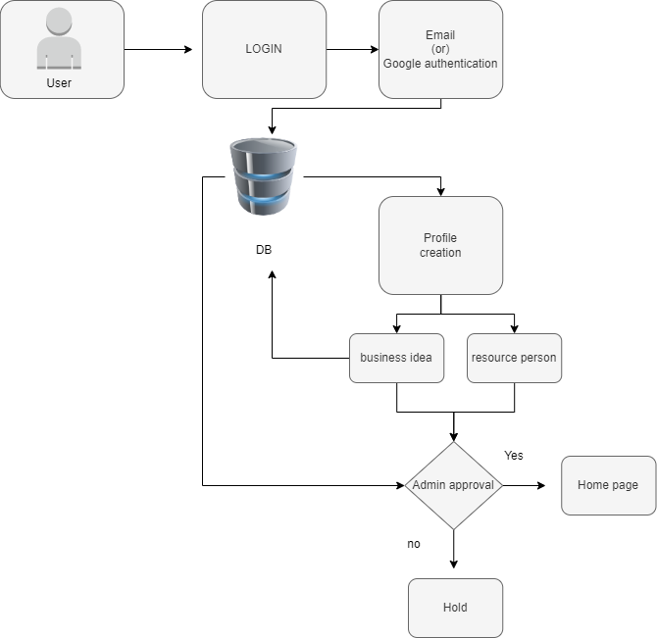

**Home screen architecture:**

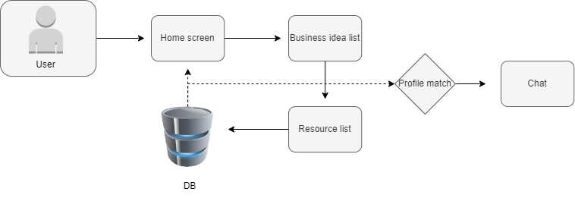

**Profile screen architecture:**

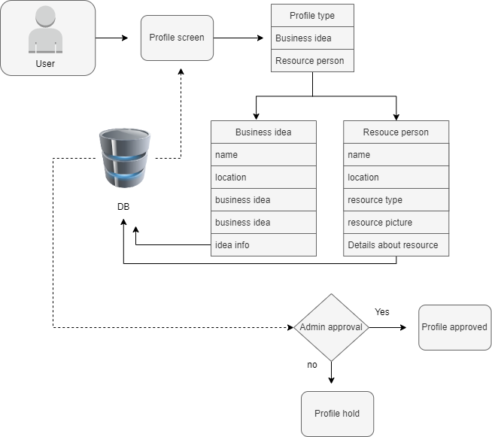

**3.2 MODULE:**

* Admin login
* User login
* Creating user profile (business idea or resource)
* User detail
* Chat

**ADMIN LOGIN: -**

* Admin login helps to maintain and request approval for the user profile
* We can create a login using google authentication where the admin can create login and the admin panel will help to give a approval for the user profile whether it’s a same one or a good one. admin will cross check those details and send the profile to the database this process of check can help to avoid some unwanted profile or duplicate profile

**USER LOGIN: -**

* User login is a normal login encryption form where the user can create a login with google authentication where ten rounds of encryption happens and the credentials will be stored in the firebase so the perticular user login cannot be hacked and retrived by the 3rd party user

**User detail:-**

* In the user details the user can update modify his data and the personal detail will not be shown in the main container
* After usere modify thew data the admin will cross verify the modified details and he will allow those data in the container

**PROFILE CREATION:-**

* In the user profile creation there are two types of profile can be created one is business idea person profile and another one is resource person profile
* Business idea profile: idea person profile where our own ideas can be posted as a business plan if the other user likes your idea then the user can approach you through the chat
* Resource:In the resource person the user should add his assert type whether it’s a land , money , jewl etc and the user will be cross verified through the admin pannel and then the profile will be allowed to the portal

**Chat:-**

* Chat is used to communicate between the users if a idea person or a resource person likes the other user profile and he wants to communicate with the other one then the chat will help to share their ideas

**CHAPER 4**

**Sign up page:-**

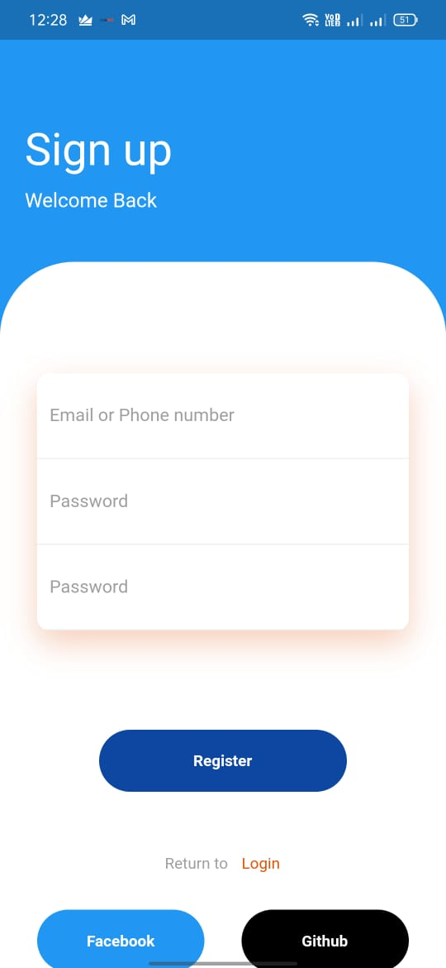

**Login page:-**

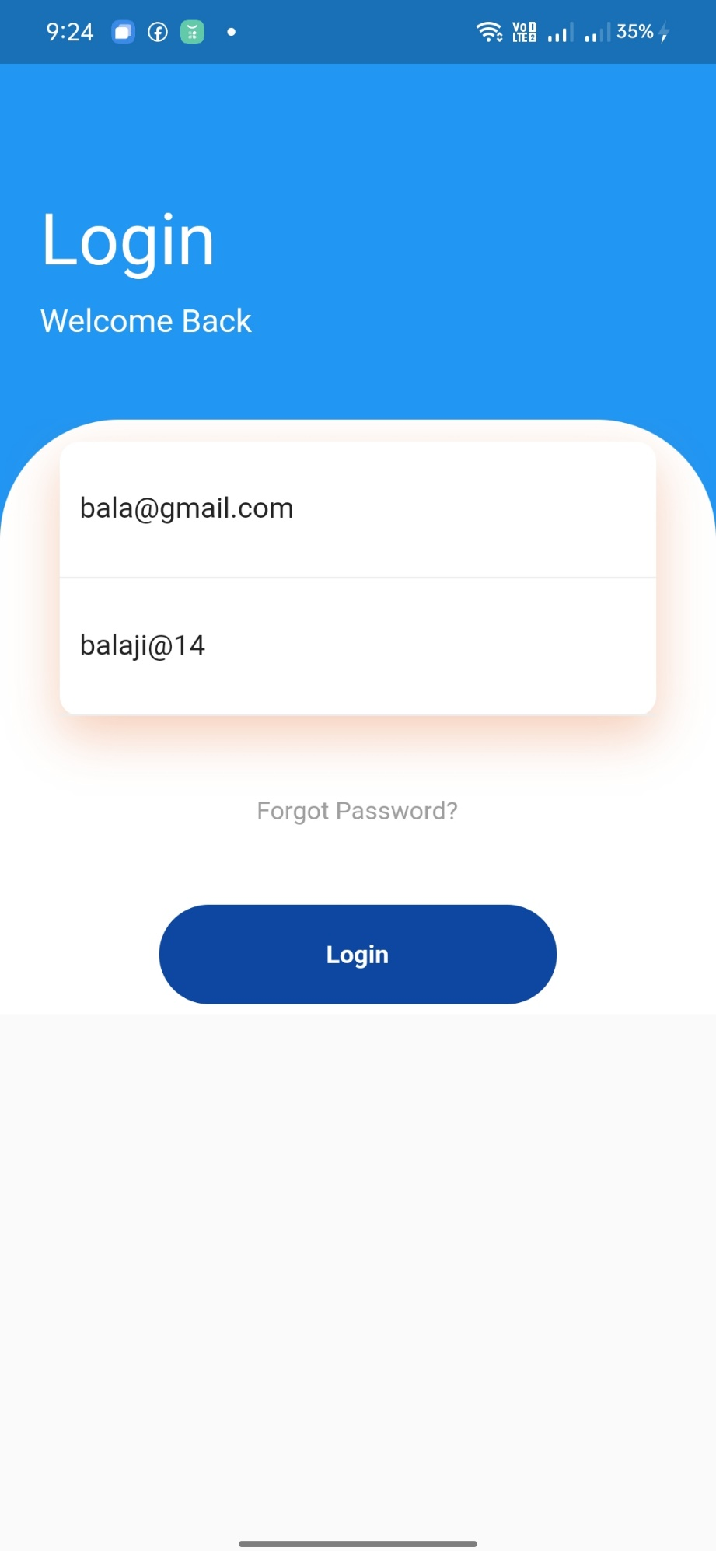

**Registration form :-**

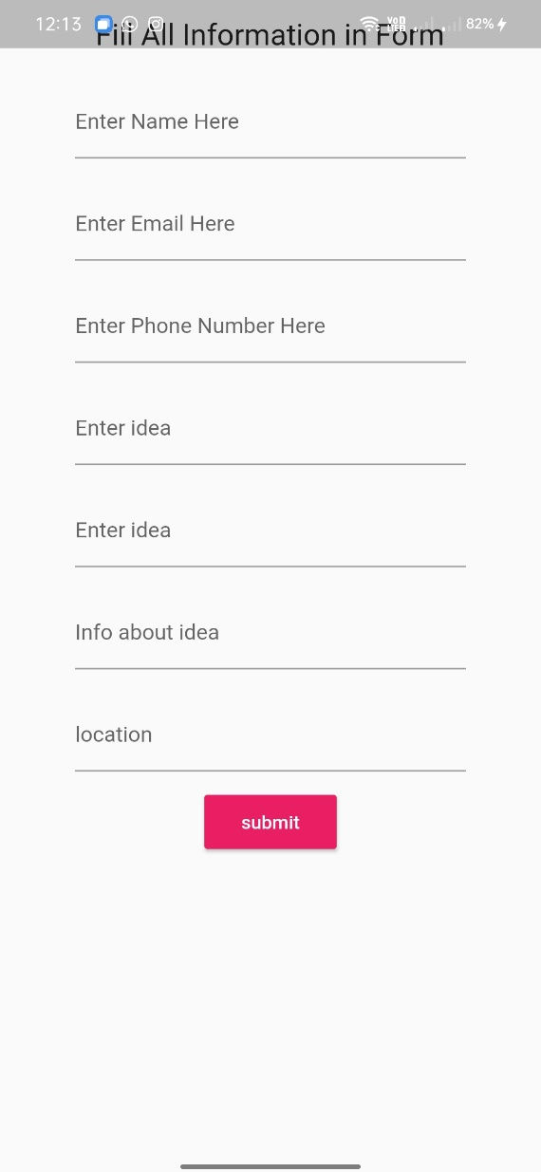

**Main page:-**

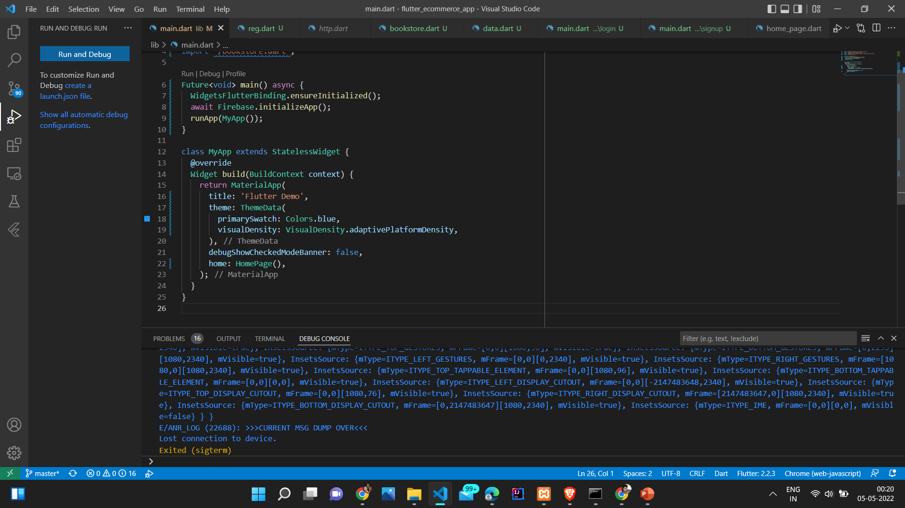

**login:-**

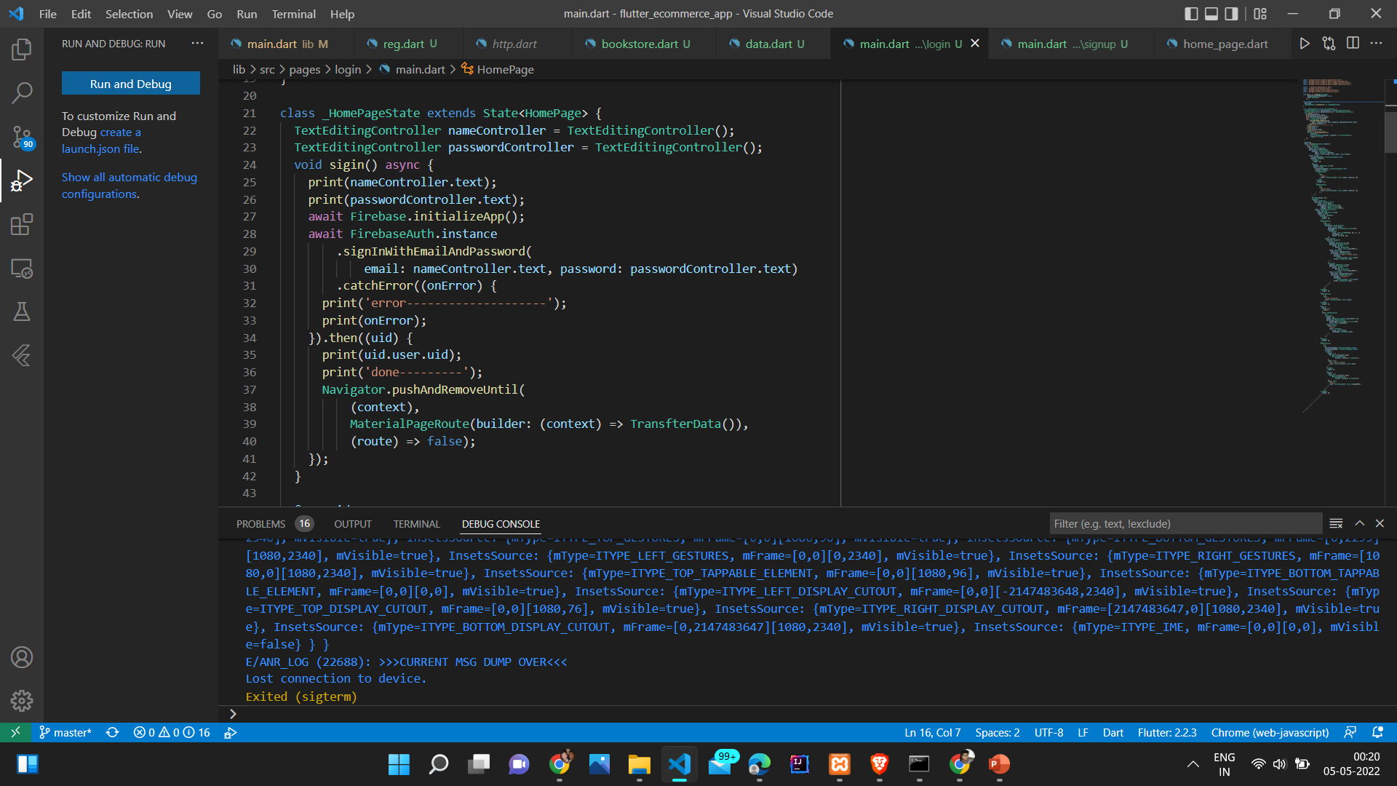

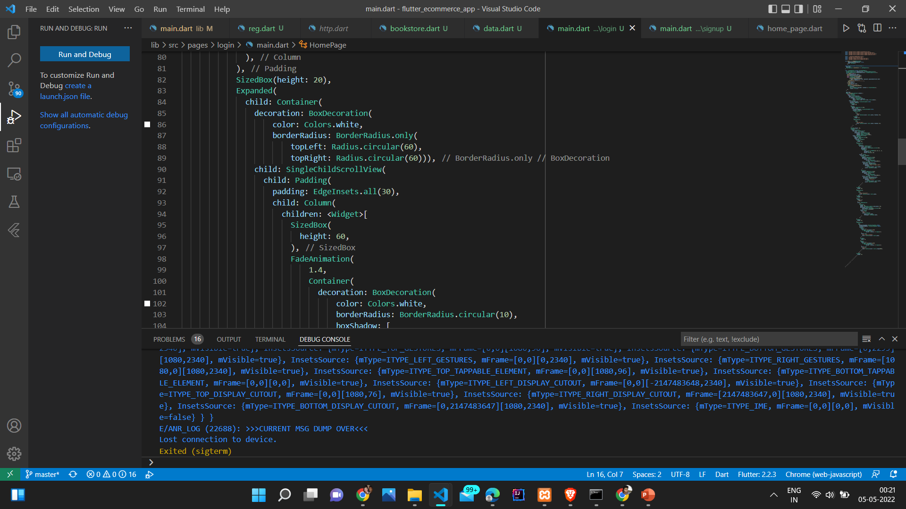

**Firebase:-**

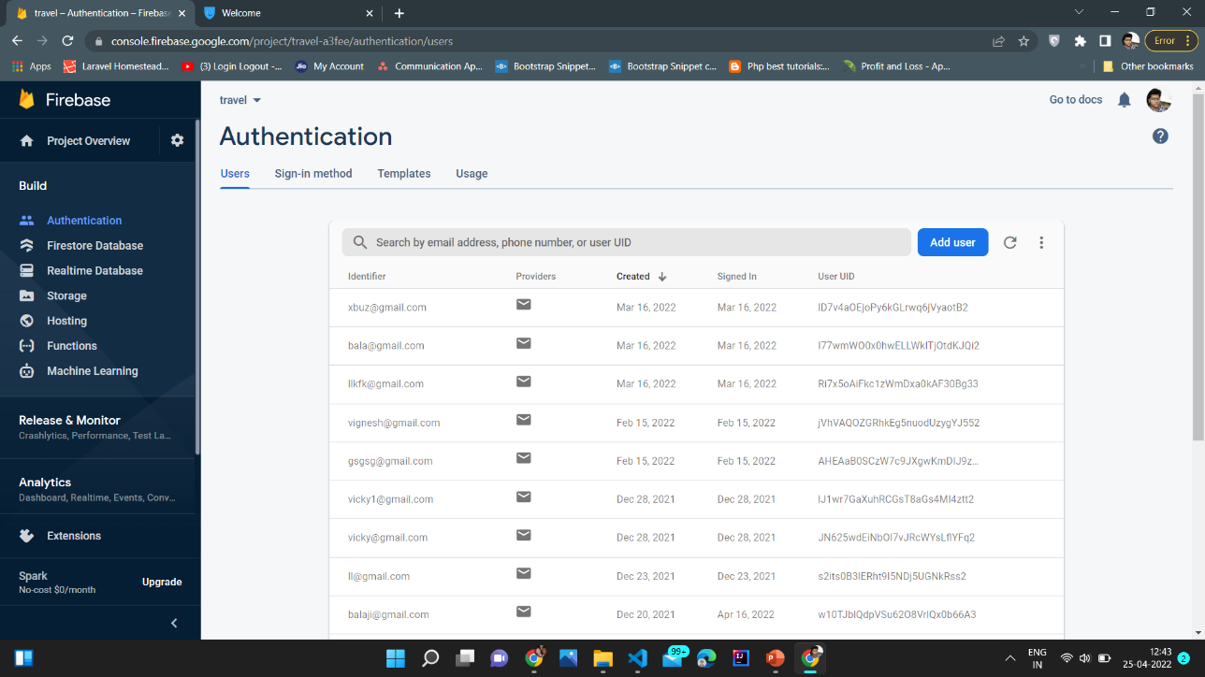

**MYSQL DATABASE:-**

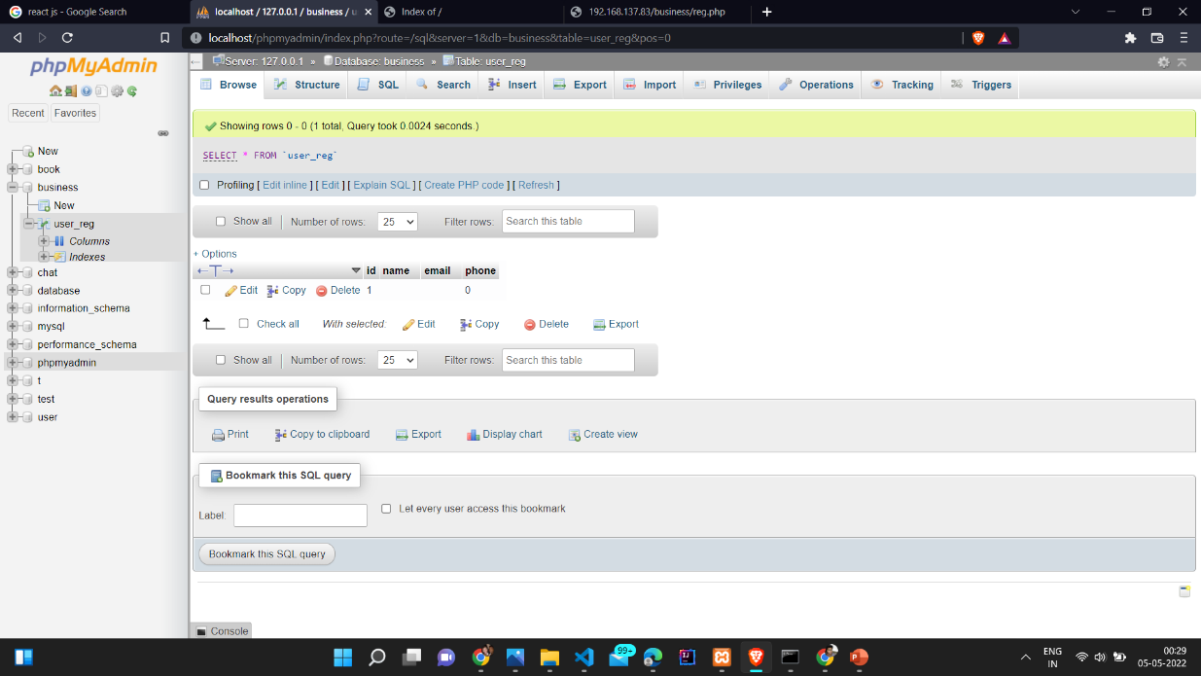

**DATABASE:**

* Here I have created a google authentication db. and a MySQL database to store the user profile where the user ideas will be store and displayed in the home page

**User credentials: -**

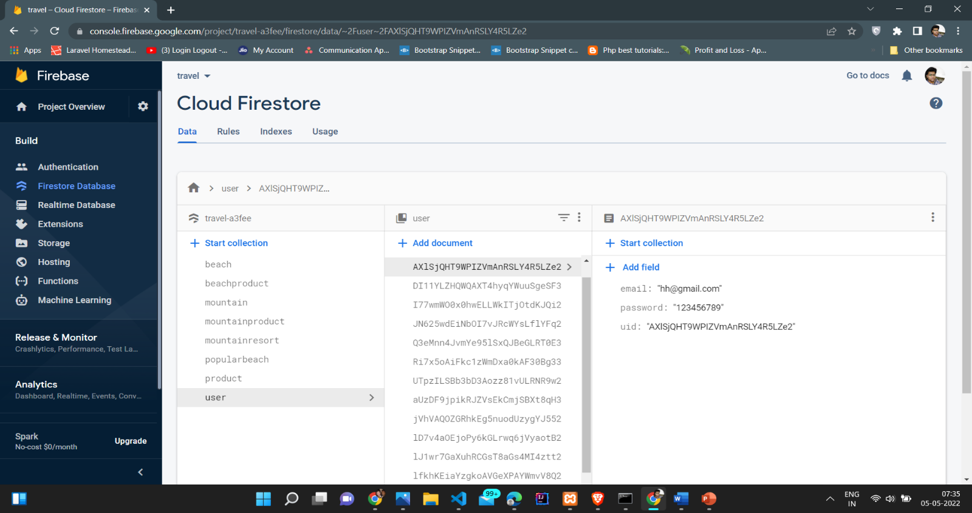

**IP address:-**

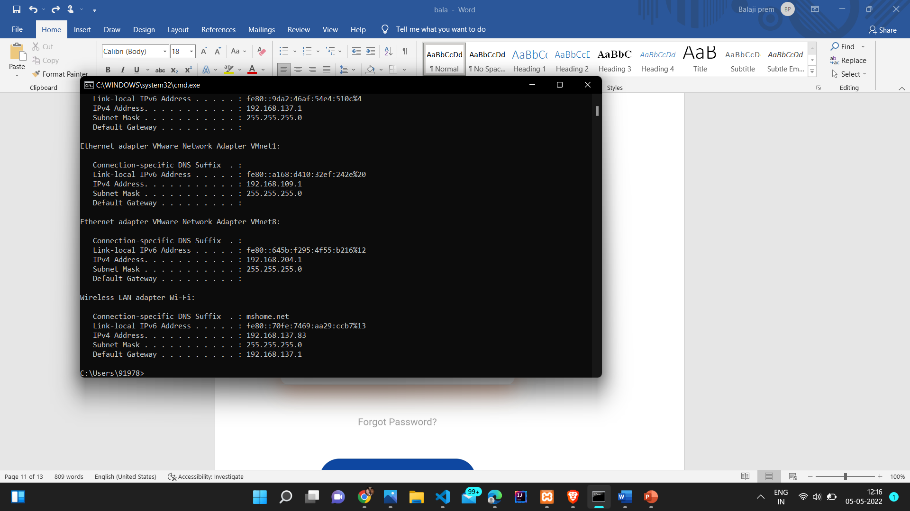

**AES 128 ALGORITHM:-**

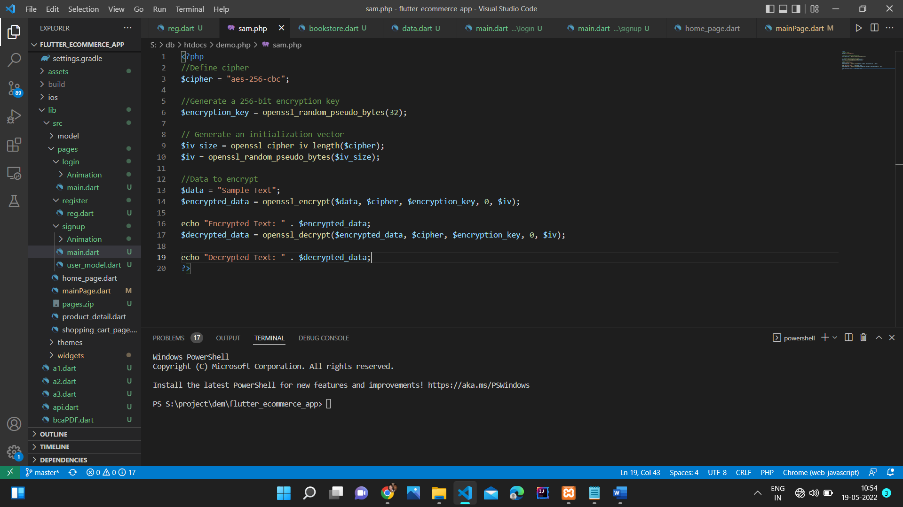

**CHAPTER 5**

**References**

* <https://www.freecodecamp.org/news/build-a-chat-app-ui-with-flutter/>
* <https://pub.dev/packages/flutter_chat_ui>
* [https://www.javatpoint.com/flutter-container](https://www.w3schools.com/html)
* https://[www.javatpoint.com/flutter-widgets](https://www.javatpoint.com/flutter-widgets)
* <https://firebase.google.com/>
* <https://serversmtp.com/what-is-smtp-server>